An Affordable High School Education:
Keeping Tuition Low


MECHANICSVILLE, MD- Chesterton Academy of St. Mary’s offers a high school that transforms lives—and transforms the culture. Our mission is to provide quality, faithfully Catholic, classical high school to more families by keeping tuition affordable. It is disheartening that less than 50% of parochial school K-8 students continue their Catholic education through high school.* A significant factor cited by parents is high tuition cost.
This Catholic high school education gap is wreaking havoc in the culture.
Our dream is a return to the days when a strong, classical, Catholic education was attainable for any middle or working-class family, large or small, living on a single income.

Thanks to a commitment to frugality, the dedication of faculty, parents, board members and the generous support of donors, Chesterton Academy is in it’s third year and is able to offer an outstanding education at a price affordable to all families. 2023-2024 Chesterton tuition is $8755, less than half of benchmark schools. The funding gap for this school year is $111,000- just $3000 per student.
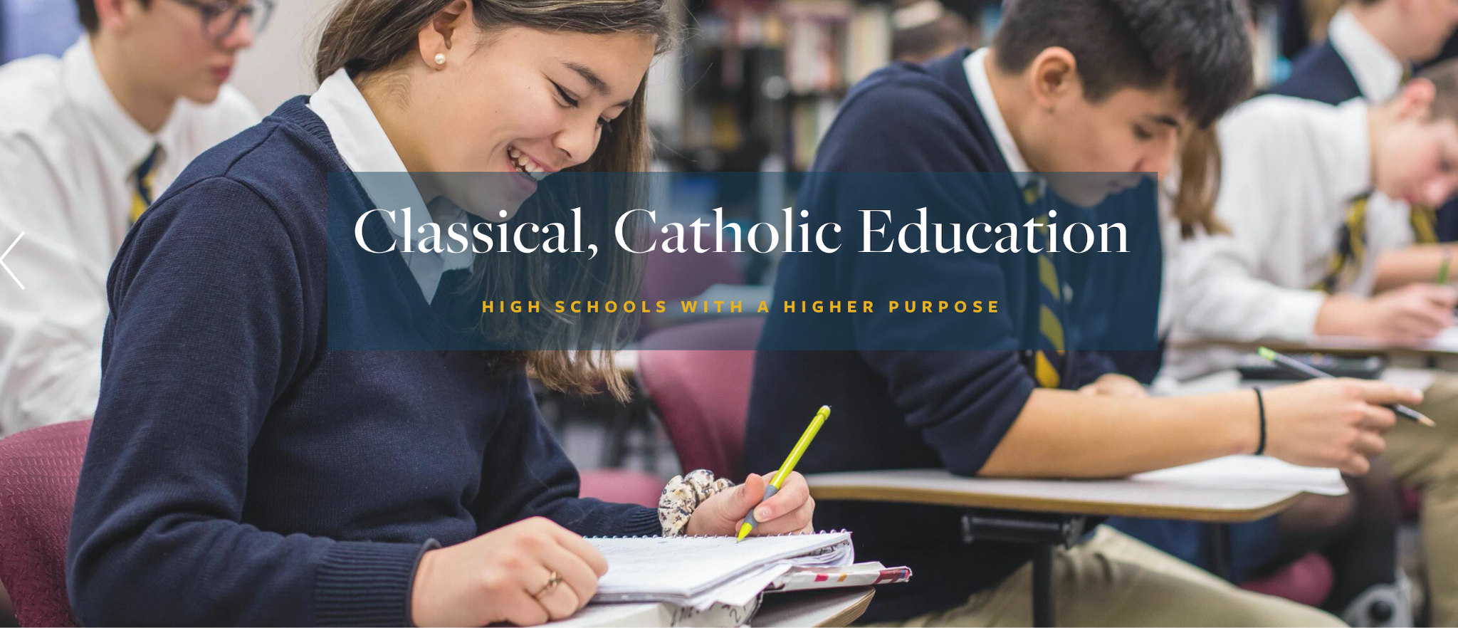
Unique characteristics of Chesterton are: daily Mass - the Catholic faith is front and center; an integrated curriculum with an emphasis on the fine arts, immersing students in truth, goodness and beauty; the use of the Socratic seminar in the classroom, so students learn to think, speak and reason well; and the 1,000 year old Oxford-style house system which facilitates and nurtures real camaraderie, responsibility and leadership, and the development of virtues.
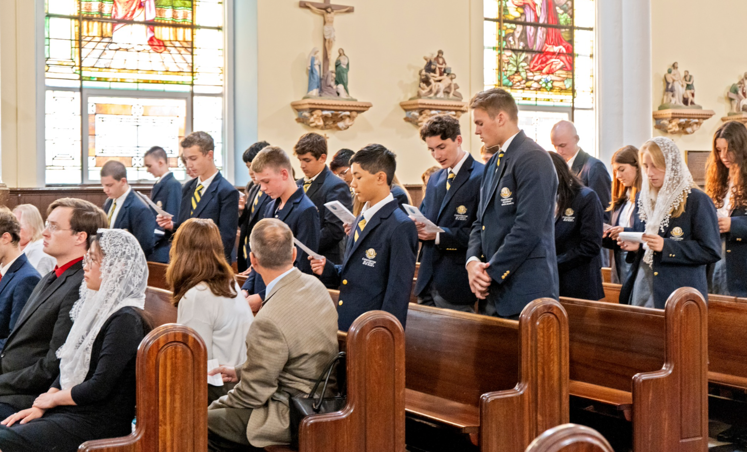
Chesterton Academy of St. Mary’s is one of 60 nationwide member schools of the Chesterton Schools Network named after journalist and prolific author of over 100 books, G.K. Chesterton, affectionately known as “The Apostle of Common Sense”. 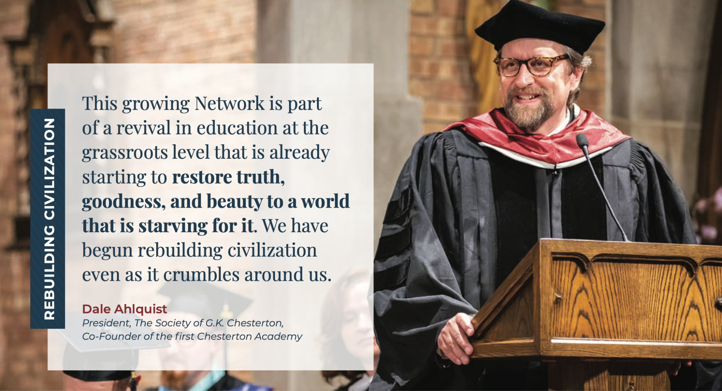
To learn more about Chesterton Academy of St. Mary’s model or curriculum, visit www.chestertonstmarys.org. For those who would like to contribute their skills and gifts to this movement as a volunteer, refer business leaders, or make a financial donation, please e-mail info@chestertonstmarys.org or visit: https://www.chestertonstmarys.org/donate
*National Catholic Educational Association

